**Input Analysis**

**Modelling of input data from the given data files**

The track of the new tram line Uithoflijn that is under our scope to simulate consists of 9 stops of 7.9 km total distance. As it obvious the tram line has two starting points, the one that starts from Centraal station and ends at the P+R De Uithof station and the reversed one from P+R De Uithof to Central station. In order to simulate both of these directions we used several datasets derived from the bus 12 which follows more or less the same route as the new tram line. The bus 12 also consists of 9 stops of 6.7 km total distance **fig1.**

|  |
| --- |
| **Bus 12 route** |
| Graadt van Roggenweg |
| 24 Oktoberplein |
| 5 Meiplein |
| Vasco da Gamalaan |
| Kanaleneiland-Zuid |
| P+R Westraven |
| Zuilenstein |
| Batau Noord |
| Wijkersloot |
| Stadscentrum |
| Merwestein |
| Fokkesteeg |
| Wiersdijk |
| Nieuwegein Zuid |

In figure 2 we can the table of correspondence between the stops of the new tram line and the bus stops. As it can be seen from the table of correspondence fig2 there is no one to one match between the station of the future tram line and the bus stops. As result we have assumed that the bus stop AZU corresponds to P+R De Uithof station and we also fitted the two missing bus stops from the correspondence table, Rubenslaan and Sterrenwijk, so that every station of the tram has a counterpart bus stop **fig3**.

|  |  |
| --- | --- |
| **Stop** | **Corr. stop route 12** |
| Centraal Station | CS Centrumzijde |
| Vaartsche Rijn | Bleekstraat |
| Galgenwaard | Galgenwaard |
| Kromme Rijn | De Kromme Rijn |
| Padualaan | Padualaan |
| Heidelberglaan | Heidelberglaan |
| UMC | Rubenslaan |
| WKZ | Sterrenwijk |
| P+R De Uithof | AZU |

|  |  |
| --- | --- |
| **Tram Stop** | **Corr. stop route 12** |
| Centraal Station | CS Centrumzijde |
| Vaartsche Rijn | Bleekstraat |
| Galgenwaard | Galgenwaard |
| Kromme Rijn | De Kromme Rijn |
| Padualaan | Padualaan |
| Heidelberglaan | Heidelberglaan |
| UMC | AZU |
| WKZ |  |
| P+R De Uithof |  |

Next, we used two datasets which contained measures of entering and leaving passengers within a month for each direction of the bus 12. Moreover, we have assumed that the passengers arrive at the stops according to a Poisson process under a rate which is determined every 15 minutes. Another assumption was that the arrival changing rates are the same among all days. In particular, the rate of the day 2/9/15 from 6:00 to 6:15 is the same for all the days in the dataset and the same goes from 6:15 to 6:30 and so forth.

**Entering passengers**

Under the aforementioned assumptions we collected the entries from every station of each direction for every 15 minutes and we used the Poisson distribution to fit into our data and determine the rate λ of the passenger arrivals. In general, Poisson distribution describes a random variable which represents the number of events (in our simulation the passenger arrivals) that occur in a time interval. So, this gave us the opportunity to exploit the convenient relationship between Poisson and Exponential distribution and use the later to find out the time between events. In **figure 4** we see the lambdas of the Poisson distribution for the first ten quarters of the day. In **figure 5(histogram-poisson fit)** it is represented our fitting in a random quarter of a peak hour.

|  |  |  |  |  |  |  |  |  |  |
| --- | --- | --- | --- | --- | --- | --- | --- | --- | --- |
| **Time** | **AZU** | **Heidelberglaan** | **Padualaan** | **De Kromme Rijn** | **Stadion Galgenwaard** | **Rubenslaan** | **Sterrenwijk** | **Bleekstraat** | **CS Centrumzijde** |
| 6:00-6:15 | 0.1 | 1.5 | 0.6 | 0.2 | 0.3 | 0.95 | 0.1 | 1.9 | 0 |
| 6:15-6.30 | 0 | 1 | 0 | 0 | 2 | 1 | 0 | 6 | 0 |
| 6.30-6:45 | 0.2 | 3.6 | 0 | 0.1 | 1.1 | 3.05 | 1 | 0.95 | 0 |
| 6:45-7:00 | 0.55 | 3.4 | 0 | 1 | 1.95 | 3.7 | 1.35 | 0.85 | 0 |
| 7:00-7:15 | 1.6667 | 3.4762 | 0.095238 | 1.2857 | 0.61905 | 2 | 0.47619 | 2.2381 | 0 |
| 7:15-7:30 | 4.65 | 8.05 | 1.7 | 1.15 | 0.9 | 5.5 | 1.5 | 2.65 | 0 |
| 7:30-7:45 | 5.3902 | 6.0488 | 0.70732 | 1.0488 | 1.6585 | 5.7317 | 1.5854 | 1.9024 | 0 |
| 7:45-8:00 | 5.8889 | 3.6984 | 0.5873 | 0.74603 | 0.96825 | 4.254 | 1.4127 | 2.3968 | 0 |
| 8:15-8:30 | 4.3735 | 3.2289 | 0.66265 | 0.3253 | 1.0602 | 2.4699 | 0.98795 | 2.2169 | 0 |
| 8:30-8:45 | 7.2295 | 3.1803 | 0.78689 | 0.42623 | 1.2295 | 2.3934 | 0.80328 | 1.9344 | 0 |

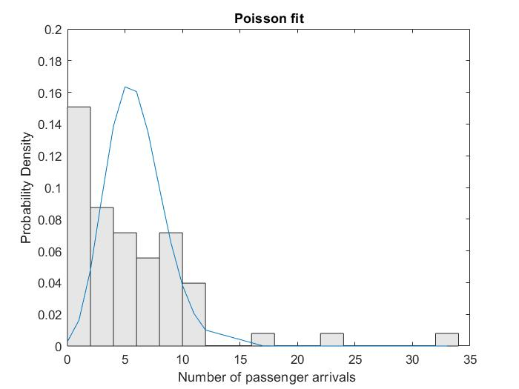

**Leaving passengers**

As for the leaving passengers we transformed our dataset into percentages (**fig)** and then we used the beta distribution function to fit into our data. We applied our fitting into every individual station in order to acquire the probability that someone will leave throughout this station within the day. Our motivation for using this specific distribution was that it is suitable model for the random behavior of percentages and proportions. Finally, we came up with a table which contains the a and b factor of beta distribution for every station. A sample of the data and the fitting distribution is represented in **figure a,b**. However, we have to note that the dataset in some cases appears to be inconsistent. In particular, there are stations that more passengers appear to leave from the tram than those who are already inside.

|  |  |  |  |  |  |  |  |  |
| --- | --- | --- | --- | --- | --- | --- | --- | --- |
| **CS Centrumzijde** | **Bleekstraat** | **Sterrenwijk** | **Rubenslaan** | **Stadion Galgenwaard** | **De Kromme Rijn** | **Padualaan** | **Heidelberglaan** | **AZU** |
| 0 | 1.5385 | 1.5625 | 9.375 | 18.966 | 6.383 | 15.909 | 40.541 | 100 |
| 0 | 4.7619 | 1.6393 | 1.6667 | 14.754 | 1.9231 | 9.8039 | 60.87 | 100 |
| 0 | 1.6129 | 0 | 6.3492 | 25 | 4.4444 | 11.628 | 78.947 | 100 |
| 0 | 4.3478 | 0 | 4.3478 | 15.909 | 5.4054 | 14.286 | 76.667 | 100 |
| 0 | 0 | 3.1746 | 9.2308 | 18.333 | 4.0816 | 23.404 | 75 | 100 |
| 0 | 4.8387 | 0 | 1.6949 | 8.6207 | 0 | 45.283 | 48.276 | 100 |
| 0 | 1.5873 | 0 | 11.29 | 14.286 | 0 | 41.667 | 57.143 | 100 |
| 0 | 1.4286 | 0 | 7.0423 | 8.8235 | 3.2258 | 40 | 61.111 | 100 |
| 0 | 0.84746 | 0.84746 | 1.6667 | 8.1967 | 2.6316 | 47.748 | 68.966 | 100 |

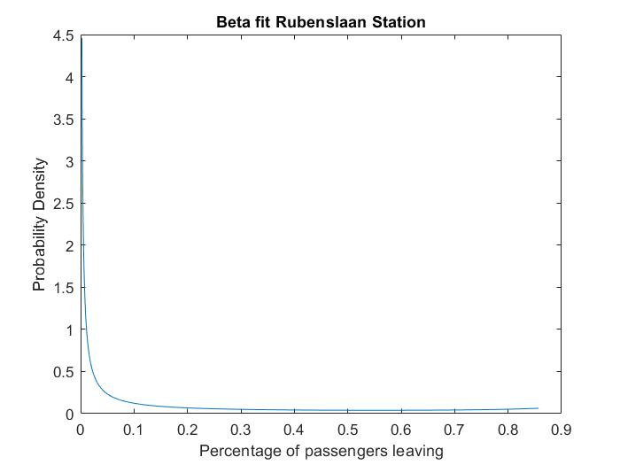

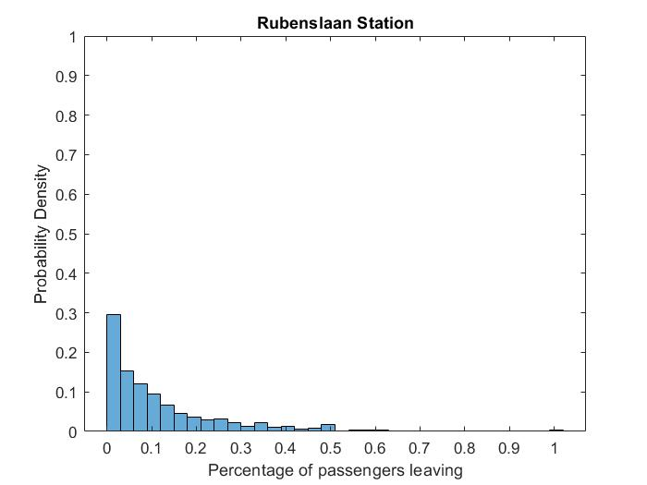

Runtimes

To model the tram runtimes we used a large set of measurements from the Nieuwegein-tramline which it consists of 14 stops. In this case we used the gamma distribution to fit into our dataset. We calculated for each stop the gamma parameters and we

